1. 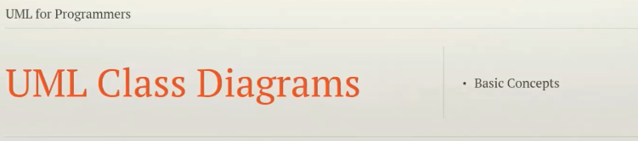
2. **Agenda**:
   1. Basics of UML Class Diagram.
3. Class Diagram represents the **Object-Oriented Classes and relationship** among them.
4. We will start looking at the **class element**.
5. In UML, a **class is represented by a rectangle** containing 3 sections.
   1. Class Name Section:
   2. Attributes Section **(Optional)**:
   3. Operations Section **(Optional)**:
6. Optional because if we want to represent just relationships among classes. That is all we’re interested.
7. 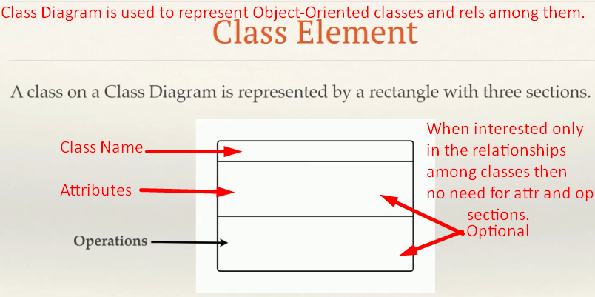
8. 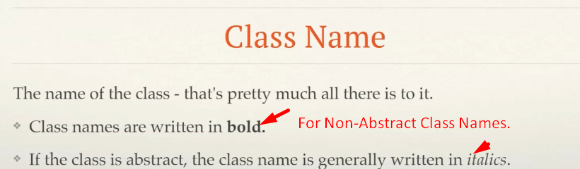
9. 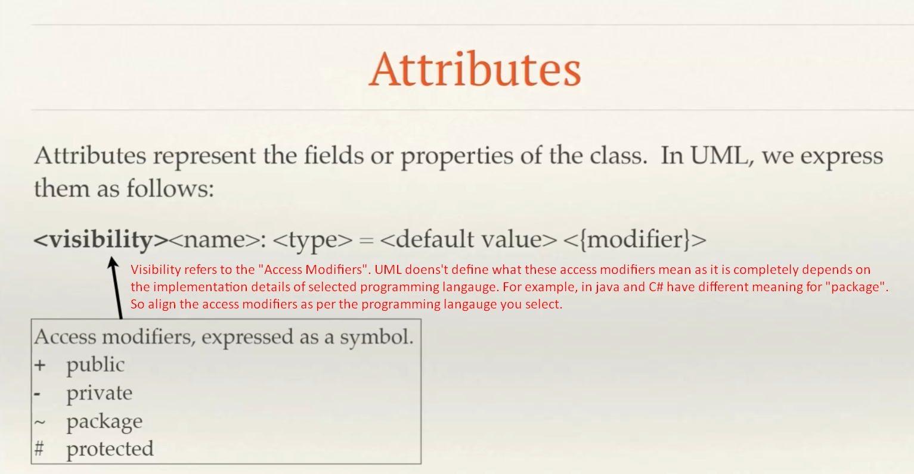
10. 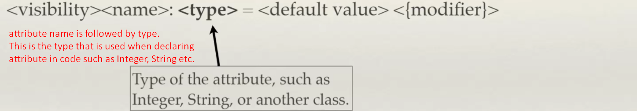
11. 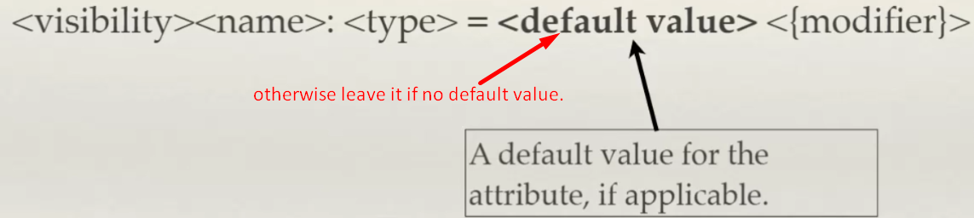
12. 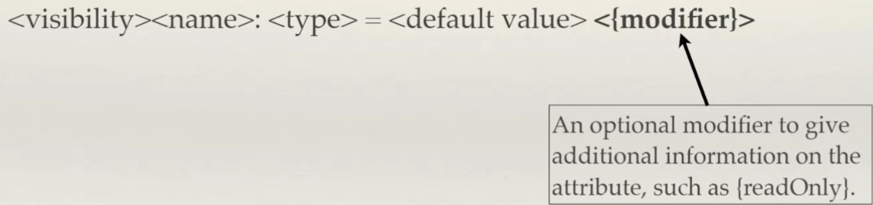
13. **Operations:**
    1. What a class can do.
14. 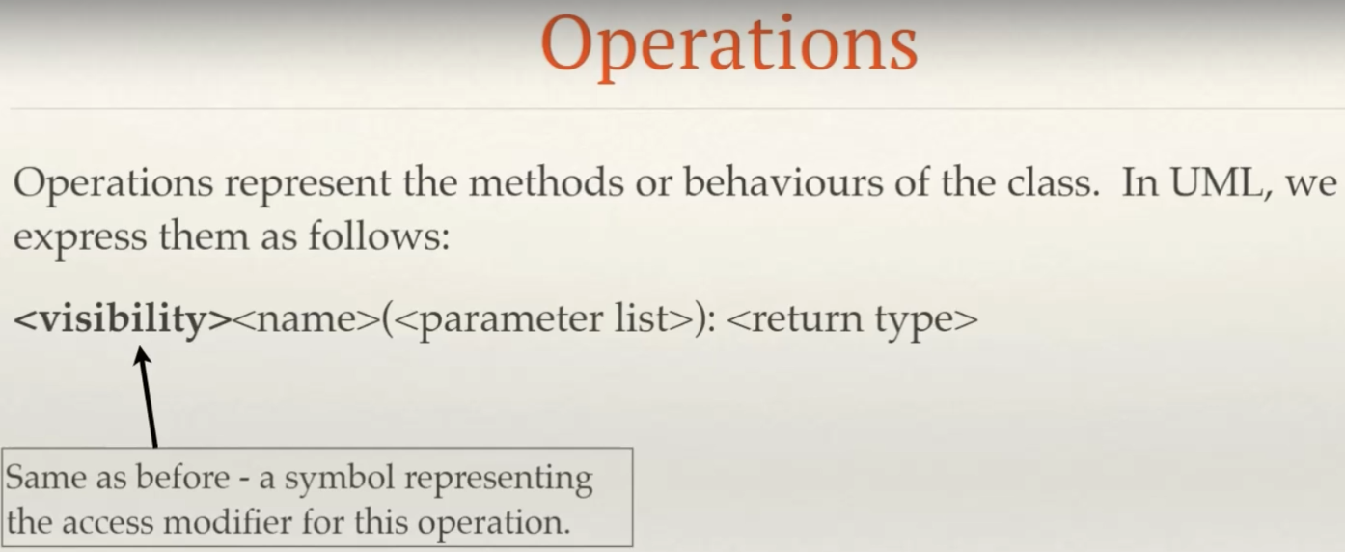
15. 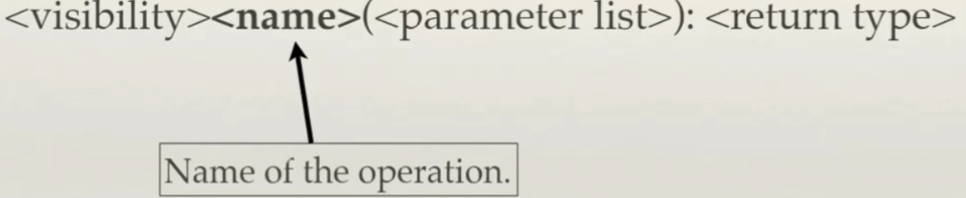
16. 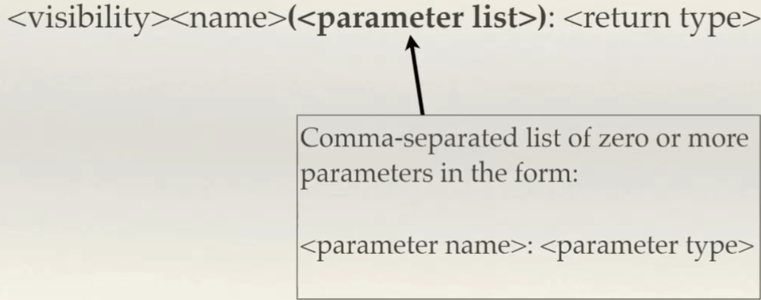
17. 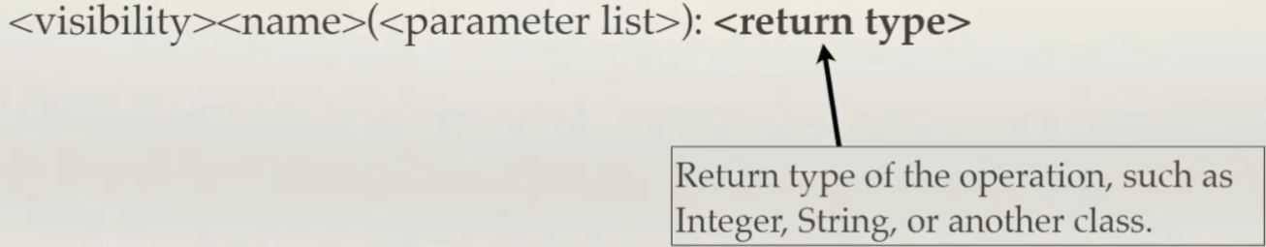
18. 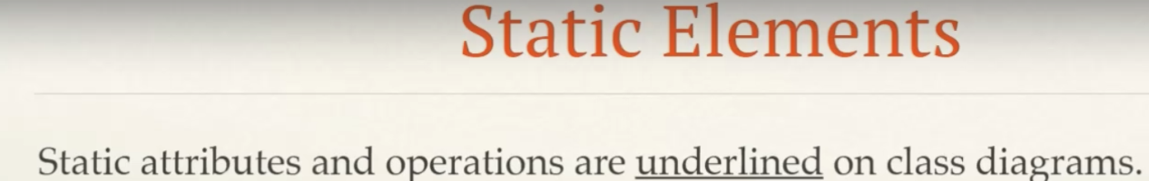
19. 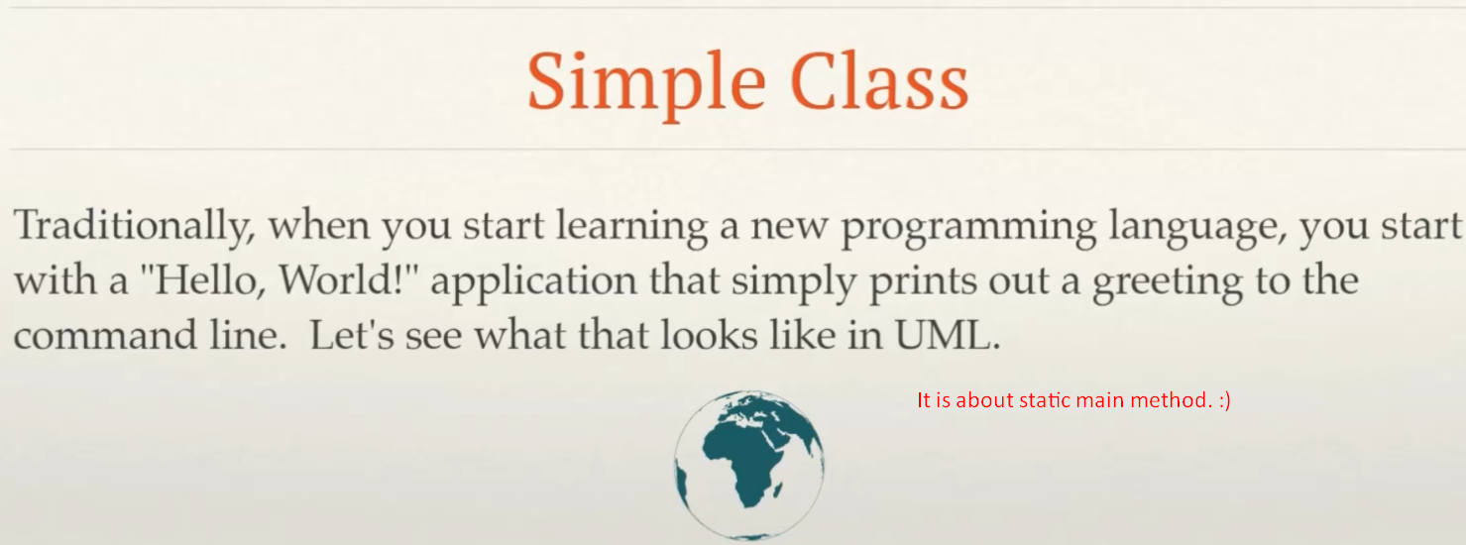
20. 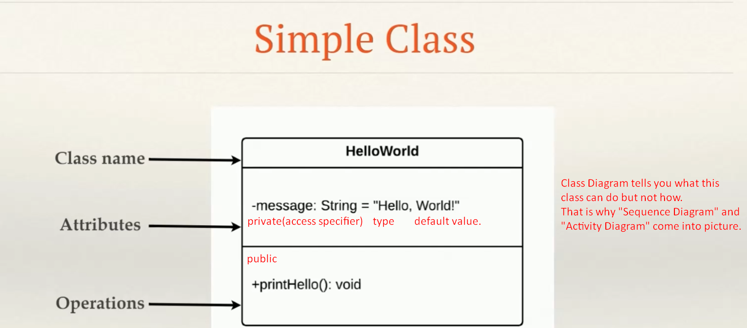
21. 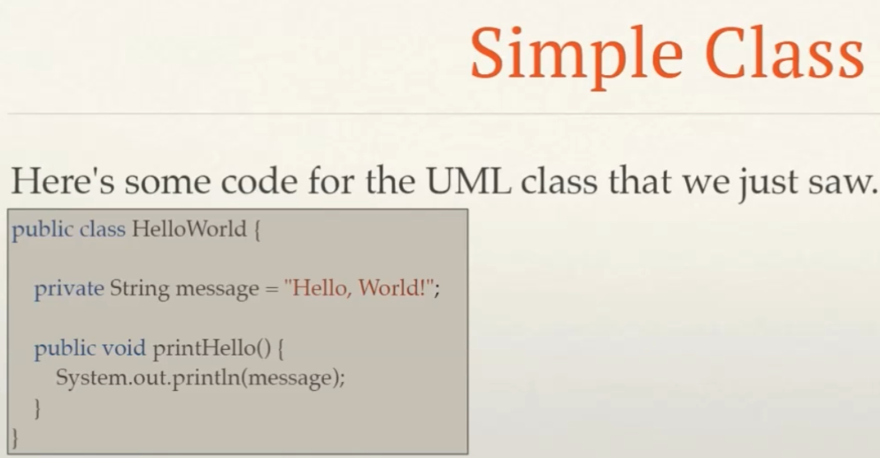
22. 